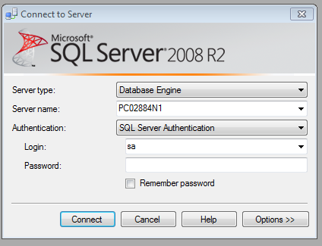

**When the students or yourself launch Management Studio please switch the Server name to your machine name without the /SQLexpress, the Authentication from “Windows Authentication” to “SQL Server Authentication”.**

**The user name/Login is: sa**

**The password is: @sql2008**